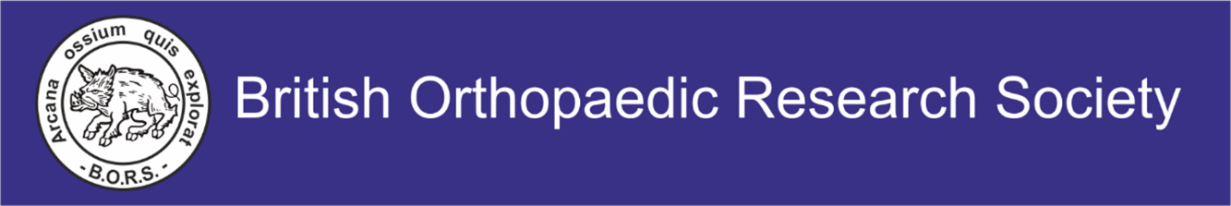

CONFIRMATION OF ELIGIBILITY
NEW INVESTIGATOR AND BEST PRESENTATION AWARDS
Application details
Name:

Abstract:

New Investigator 2026
Eligibility criteria:
- Member of BORS (at the time of applying and during the annual meeting)
- In training or within 5 years of attainment of higher degree or completion of specialist training
- Will be the presenting author of the abstract

Please tick which of these you are applying for:

New Investigator Award

Best Presentation Award (Andrew Sprowson Award for Translational Research)

The above applicant has applied for an Award when submitting his/her abstract for the above meeting. Please fill in your details below to verify their eligibility.
I confirm that the applicant meets the above criteria:

Head of Department Name:

Head of Department Email:

Signature:

Date:

Please print this form, complete the details below and return by the abstract deadline 1st May 2026. Please email completed copy to bors2026-conf@strath.ac.uk

